ST10439133 INSY6112 EXAM ANSWERS:

QUESTION 1:

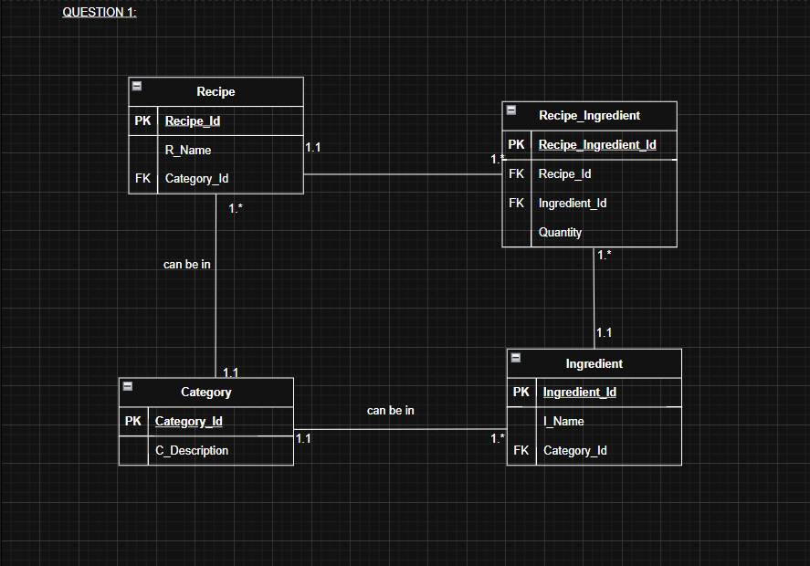

QUESTION 2:

QUESTION 3: (also submitted as a text file)

CREATE SCHEMA EXAMQ3;

USE EXAMQ3;

-- Q.3.1

-- Create Student table

CREATE TABLE Student (

StudentID INT PRIMARY KEY AUTO_INCREMENT,

StudentName VARCHAR(50) NOT NULL,

StudentSurname VARCHAR(50) NOT NULL,

StudentNumber VARCHAR(20) UNIQUE NOT NULL

);

-- Q.3.2

-- Create Lecturer table

CREATE TABLE Lecturer (

LecturerID INT PRIMARY KEY AUTO_INCREMENT,

LecturerName VARCHAR(50) NOT NULL,

LecturerSurname VARCHAR(50) NOT NULL

);

-- Q.3.3

-- Create Tutorial table

CREATE TABLE Tutorial (

TutorialID INT PRIMARY KEY AUTO_INCREMENT,

StudentID INT NOT NULL,

LecturerID INT NOT NULL,

TutorialDate DATE NOT NULL,

TutorialTime TIME NOT NULL,

TutorialDuration INT NOT NULL, -- duration in minutes

FOREIGN KEY (StudentID) REFERENCES Student(StudentID),

FOREIGN KEY (LecturerID) REFERENCES Lecturer(LecturerID)

);

-- Q.3.4

-- Insert data into Student table

INSERT INTO Student (StudentName, StudentSurname, StudentNumber)

VALUES ('Debbie', 'Theart', '123456');

INSERT INTO Student (StudentName, StudentSurname, StudentNumber)

VALUES ('Thomas', 'Duncan', '654321');

INSERT INTO Lecturer (LecturerID, LecturerName, LecturerSurname)

VALUES ('1', 'Zintle', 'Nukani');

INSERT INTO Lecturer (LecturerID, LecturerName, LecturerSurname)

VALUES ('2', 'Ravi', 'Maharaj');

INSERT INTO Tutorial (TutorialID, TutorialDate, TutorialTime, TutorialDuration, StudentID, LecturerID)

VALUES ('1', '2025-01-15', '9:00', '180', '2', '1');

INSERT INTO Tutorial (TutorialID, TutorialDate, TutorialTime, TutorialDuration, StudentID, LecturerID)

VALUES ('2', '2025-01-18', '15:00', '240', '2', '2');

INSERT INTO Tutorial (TutorialID, TutorialDate, TutorialTime, TutorialDuration, StudentID, LecturerID)

VALUES ('3', '2025-01-20', '10:00', '180', '1', '1');

INSERT INTO Tutorial (TutorialID, TutorialDate, TutorialTime, TutorialDuration, StudentID, LecturerID)

VALUES ('4', '2025-01-21', '11:00', '180', '2', '1');

-- Q.3.5

-- Select tutorials scheduled between 2025-01-16 and 2025-01-20 inclusive

SELECT *

FROM Tutorial

WHERE TutorialDate BETWEEN '2025-01-16' AND '2025-01-20';

-- Q.3.6

-- Get students with their total number of tutorials, sorted by count descending

SELECT

S.StudentName,

S.StudentSurname,

COUNT(T.TutorialID) AS TotalTutorials

FROM

Student S

JOIN

Tutorial T ON S.StudentID = T.StudentID

GROUP BY

S.StudentID, S.StudentName, S.StudentSurname

ORDER BY

TotalTutorials DESC;

-- Q.3.7

-- Create a view for students who booked tutorials with Lecturer ID 2

CREATE VIEW StudentsWithLecturer2 AS

SELECT DISTINCT

S.StudentName,

S.StudentSurname

FROM

Student S

JOIN

Tutorial T ON S.StudentID = T.StudentID

WHERE

T.LecturerID = 2

ORDER BY

S.StudentSurname ASC;

SELECT * FROM StudentsWithLecturer2;

QUESTION 4:

